**Creation of centos server VMs is done:**



**Making the two machines communicate:**

* **R-serverA IP address:**

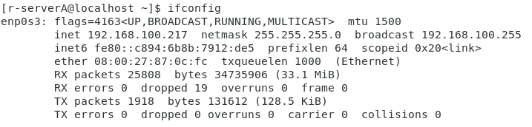

* **R-serverB IP address:**

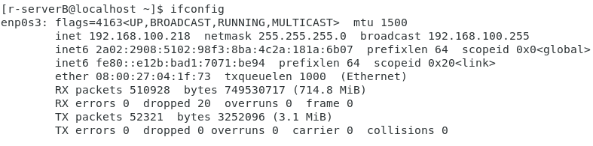

* **Server A communicating to Server B using ping command:**

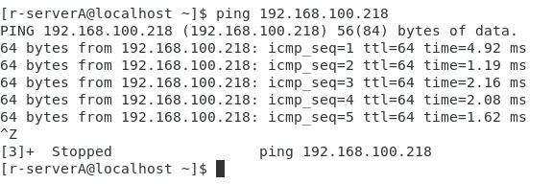

* **Creating Directory:**

* **Creating File:**

* **Changing the permissions for “test” directory:**

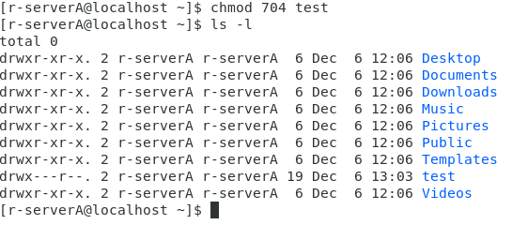

* **Compressing the directory using tar command:**

-c 🡪 means create archive.

-z 🡪 means the type of compression is gzip.

-v 🡪 means verbose, which basically means output the process of the command.

-f 🡪 means filename.

Then we specify both the new archive file name and then tha name of directory or file we want to compress.

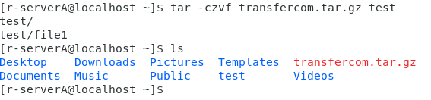

**SCP protocol**

This protocol is used to transfer files securely from one device to another. By default the scp protocol transfers the file encrypted. But you can specify what type of encryption using the -c option, which means cipher, and select the algorithm you want to encrypt the transfer of files.

In the below figure, I’ll break down the command into smaller sectors as I applied more than one concept.

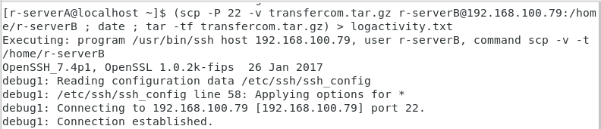

* First scp command:

|  |  |
| --- | --- |
| scp -P 22 -v transfercom.tar.gz username@*ip-address*:/home/user-directory | |
| -P 22 | -P means to specify port. I wrote 22 which refers to SSH tcp port. |
| -v | Displaying the process of the command. |
| Transfercom.tar.gz | Filename to be transferred. |
| username@*ip-address* | Username @ that machines address. |
| /home/userdirectory | Transfer to this directory. |

To ensure that the transfer is encrypted, I purposely typed the option -v, to display how the command process goes. As you can see in the below screenshot, the SSH-2.0 is enabled. Also you can see the process of establishing the session between the two servers.

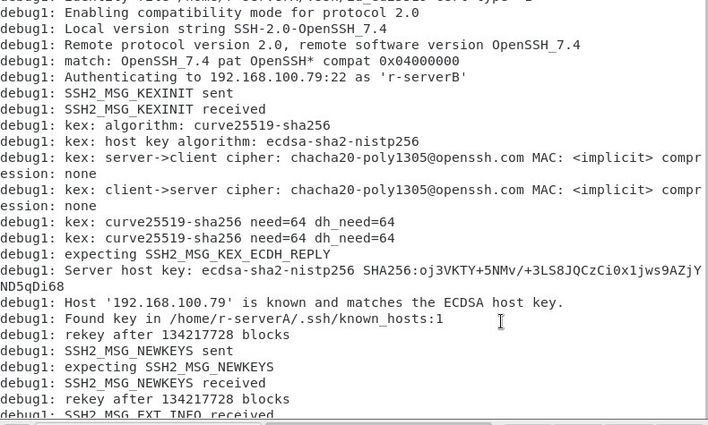

Once the transfer is successful it is requested from us to implement a log file for the activity, along with displaying the time and date, and the files that are compressed. And save the output from this command in the file created. **Note: the scp output won’t be logged. Scp is known that it does not create any logs when transferring the files.**

The other half of the command I wrote is:

|  |  |
| --- | --- |
| ; date ; tar -tf filename.tar.gz) > logactivity.txt | |
| date | Displays the day, date and time. |
| Tar -tf filename.tar.gz | To display what is inside the archive. |
| () | The parenthesis is used to ensure that all the commands output is then saved in the file, which is directed using > |
| > logactivity.txt | Directing the output to be saved in file. |

So the full form the issued command is:

(scp -P 22 -v transfercom.tar.gz username@*ip-address*:/home/user-directory ; date ; tar -tf transfercom.tar.gz) > logactivity.txt

* **Checking if the transfer is successful in server B:**

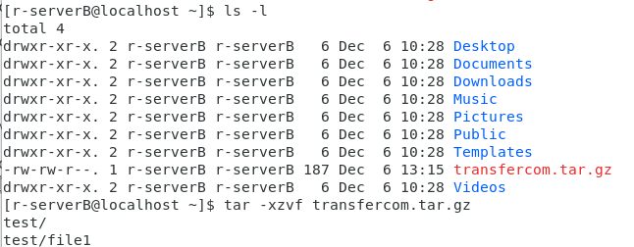

* **Changing the permissions of the file and keep what is needed:**

